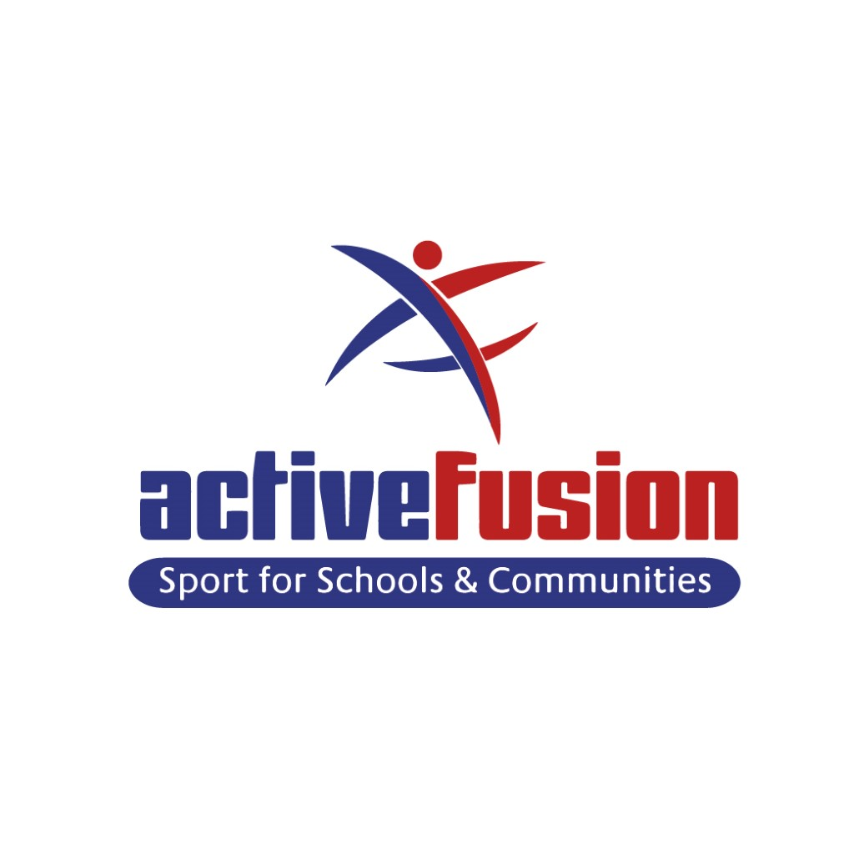 Trustee JOB & PERSON SPECIFICATION

About Active Fusion

Mission: ‘Be the best you can be’

Vision: To help every child develop a love for being active by developing potential and creating positive habits which last a life time.

Active Fusion is a charitable organisation with a proven track record of supporting local young people who face extreme challenges and hurdles. We provide opportunities for young people to ‘be the best they can be’ and to create sustainable pathways into further education, training and employment. Our team works with over 23,000 young people each year.

Our 3 main objectives are to:

- Increase physical well-being
- Increase employability
- Improve the quality of teaching and learning within Physical Education.

Underpinning these 3 areas of provision is a range of services which both schools and communities can access to support the physical health and well-being of the current and next generation of young people. These include:

- Leadership pathways from 5 - 18 years
- Apprenticeship qualifications and accredited courses
- Professional development training courses for teachers and other school staff
- Over 80 sports competitions, events, and conferences.
- Gold and Silver P.E. Sport and physical wellbeing packages for schools
- PE specialist curriculum support and delivery
- Sports and physical activity holiday programmes focusing on essential life skills
- Specialist dance packages

Physical Education, physical activity and well-being have the potential to make a significant contribution to an individual’s quality of life. By putting the child at the heart of everything we do we have the following principles which guide our work:
Develop - We strive to develop the whole person, giving them the best start in life.
Challenge - We challenge ourselves, and others to be the best they can be
Passion - We show pride, enthusiasm and dedication
Professional - We are professional in all the work we do, striving for perfection.
Inclusive - We provide inclusive services, believing that everybody has the opportunity to be as active and healthy as they can possibly be.
Integrity - We will do what we say, demonstrate good character and encourage a relationship of mutual trust and respect.

Trustee Positions Various:

We are currently seeking applications from individuals interested in becoming a trustee. Our immediate priority is to find individuals with experience and skills in fundraising or corporate partnerships as well experience in human resources and legal.

By becoming a trustee with Active Fusion, you will have the opportunity to help the charity offer more young people and families the chance to be active and create positive habits for life, making a huge difference to the lives of many people.

In return we can offer you the chance to extend your professional network, develop your own skills and experience, be a part of a growing organisation, work as part of a team, gain an understanding of new subjects or issues, make new contacts and develop lasting partnerships.

Applications for the role of trustee will be taken all year round.

An application pack can be downloaded from:
www.activefusion.org.uk/careers/vacancies-2/
Or by emailing: info@activefusion.org.uk

Active Fusion is committed to safeguarding the welfare of all young people and vulnerable adults, the successful applicant(s) will be subject to an enhanced DBS Disclosure.

Active Fusion
Trustee
Job Description

Responsible to: Chair of trustees/Charity director

Purpose of the job: To receive assets from donors, safeguard them and apply them to charitable purposes of Active Fusion.
Duties and Responsibilities:

- Ensure that Active Fusion complies with its governing document (its articles of association) charity law, company law and any other relevant legislation or regulations
- Ensure that Active Fusion pursues its objectives as defined in its governing document
- Ensure Active Fusion applies its resources exclusively in pursuit of its objectives. For example, it must not spend money on activities which are not included in the objectives, however worthwhile they may be.
- Contribute actively to the board of trustees by giving firm strategic direction to Active Fusion, setting overall policy, defining goals, setting targets and evaluating performance against agreed targets.
- Safeguard the good name of Active Fusion.
- Live the values of Active Fusion
- Ensure the financial stability of Active Fusion.

Special Conditions
In addition to the above statutory duties, each trustee should use any specific skills, knowledge or experience they have to help the board of trustees reach sound decisions. This may involve leading discussions, identifying key issues, providing advice and guidance on new initiatives and evaluating or offering advice on other areas in which the trustee has particular expertise.

Time commitment:

- Trustees are expected to attend bi-monthly meetings throughout the year, one of which will be an extended meeting to incorporate the AGM. Meetings are normally held outside standard working hours, commonly 5pm – 6.30pm.
- There may be the need for additional sub-group meetings at times during the year. Trustees will be required to attend the groups relevant to their experience and skills.
- There may be a need to bring all trustees and staff together for strategic planning from time to time.
- Trustees will be expected to attend a number of key Active Fusion events over the course of the year.

ACTIVE FUSION – Trustee Person Specification
Every Trustee MUST have: | Essential | Desirable
A commitment to the mission of Active Fusion | *
A willingness to meet the time requirement | *
Integrity | *
Strategic vision |  | *
Good, independent judgement | *
An ability to think creatively |  | *
A willingness to speak their mind | *
An understanding and acceptance of legal duties, responsibilities and liabilities of trusteeship | *
An ability to work effectively as a member of a team and to make decisions for the good of Active Fusion | *
The board of trustees collectively needs skills and experience in the following areas: We expect this to be through multiple appointments.
Fundraising | *
Financial management, income generation and enterprise | *
Public Policy & Public affairs |  | *
National & local voluntary sector |  | *
National & local government & statutory bodies |  | *
Digital strategy, social media, marketing |  | *
HR | *
Social investment & Impact | *
Collaborative partnerships |  | *
IT | *
Education | *
Business investment | *
Corporate partnerships | *

This list is not exhaustive. We welcome applications from anyone who possesses any skills and knowledge which will enhance the charity.

